**Day 1:**

* Node:
  + Runtime platform, single threaded, it runs JavaScript, opensource ,light weight , V8 engine ,event driven
  + Introduced in 2009 by Rayan

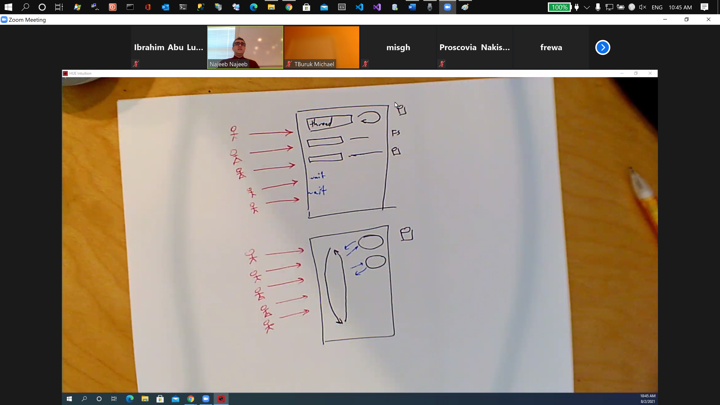

* Node consist of :
  + Event loop
    - Run java scripts on java scrip engine (like V8-Chrome java script engine).
    - Single threaded
  + Libuv : multithreaded library in node takes care of operations .
  + 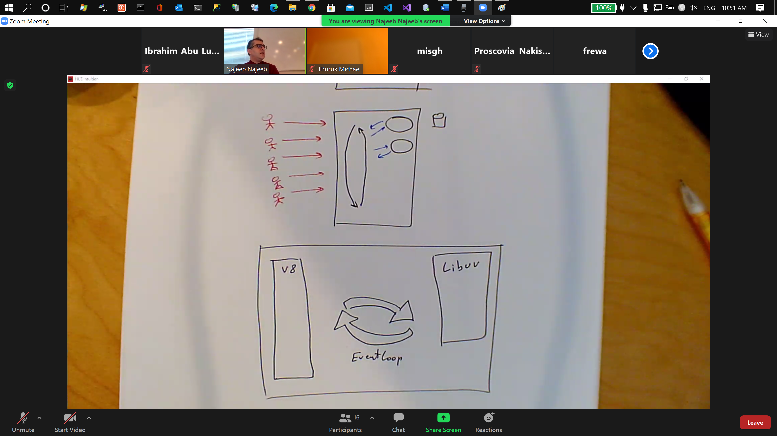
  + 2GHz = 2,000,000,000 =>operation in a second =0.5ns for 1 operation
  + 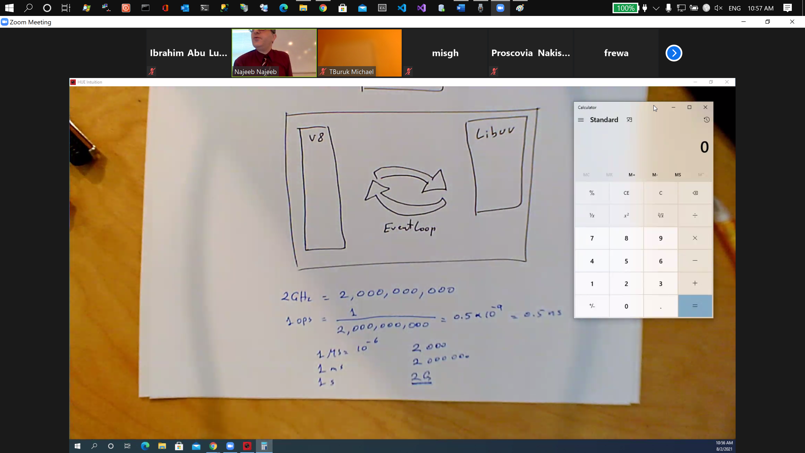
* Complier is singe or multi threaded.
  + So its wrong to say JavaScript is single threaded : no compiler or engines are single threaded.
* Zoom in => Event loop
* Libuv -> multithreaded.
* Node single threaded but multi-threaded in the IO operations
* Node languages: TypeScript, JavaScript , c++ (Libuv)(v8)
* Event Loop: 9
  + Queues
    - Timer
      * setIntervals
      * setTimeout
    - Pending callback
      * Less important callbacks
    - Idle
      * Node internal usage
    - Poll
      * I/O call back (most important callbacks)
    - Check
      * Set immediate
    - Close callback
      * Close events
    - A separate queue is next tick queue (they should call it highest priority queue ) it check it after each call back. (process.nextTick(function))
    - A separate queue is micro task queue. => queue in V8: if there is no more in next tick queue this will be checked .(queue.microtask(function))
    - 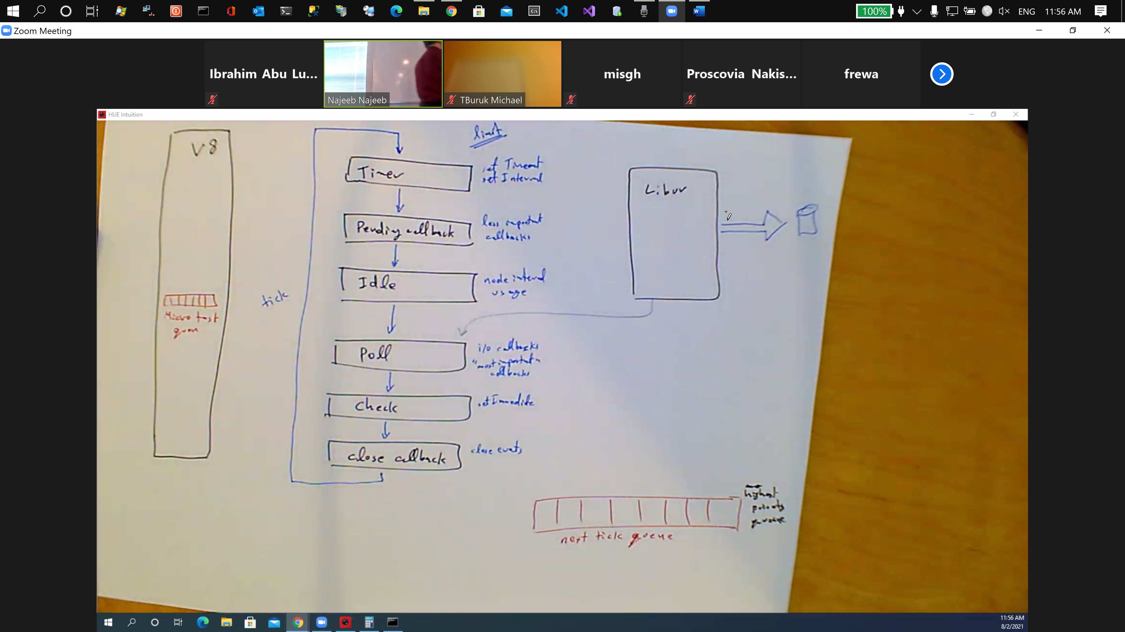
  + Queues take request and send it to the engine
  + 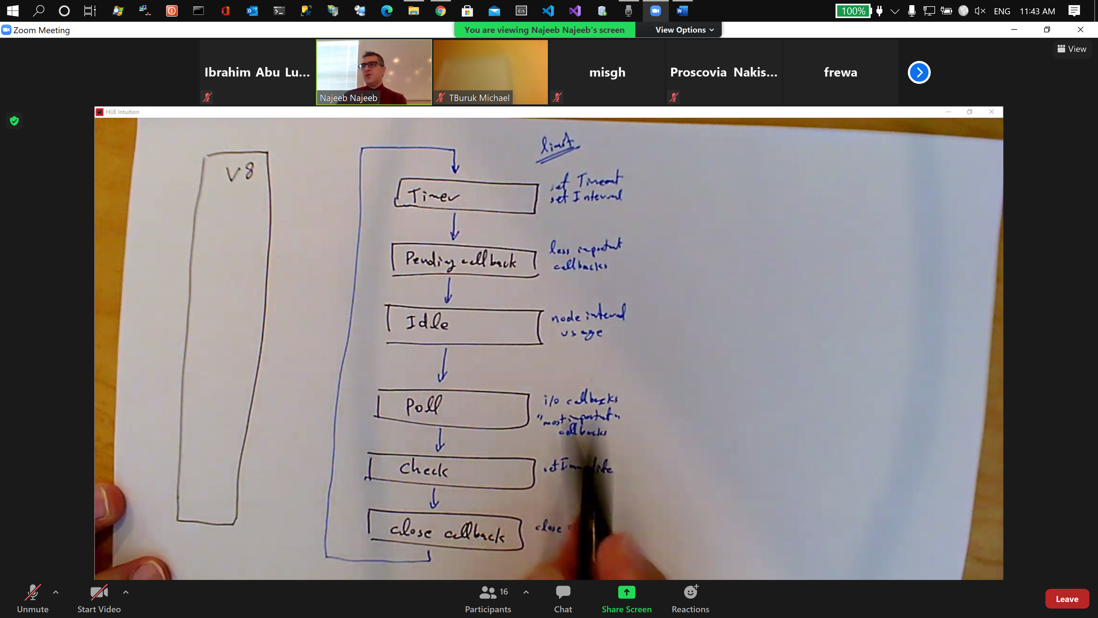
  + What inside queues contain calls back for request.
  + Limit variable on the queues.
  + Libuv fills the pull queue
  + 